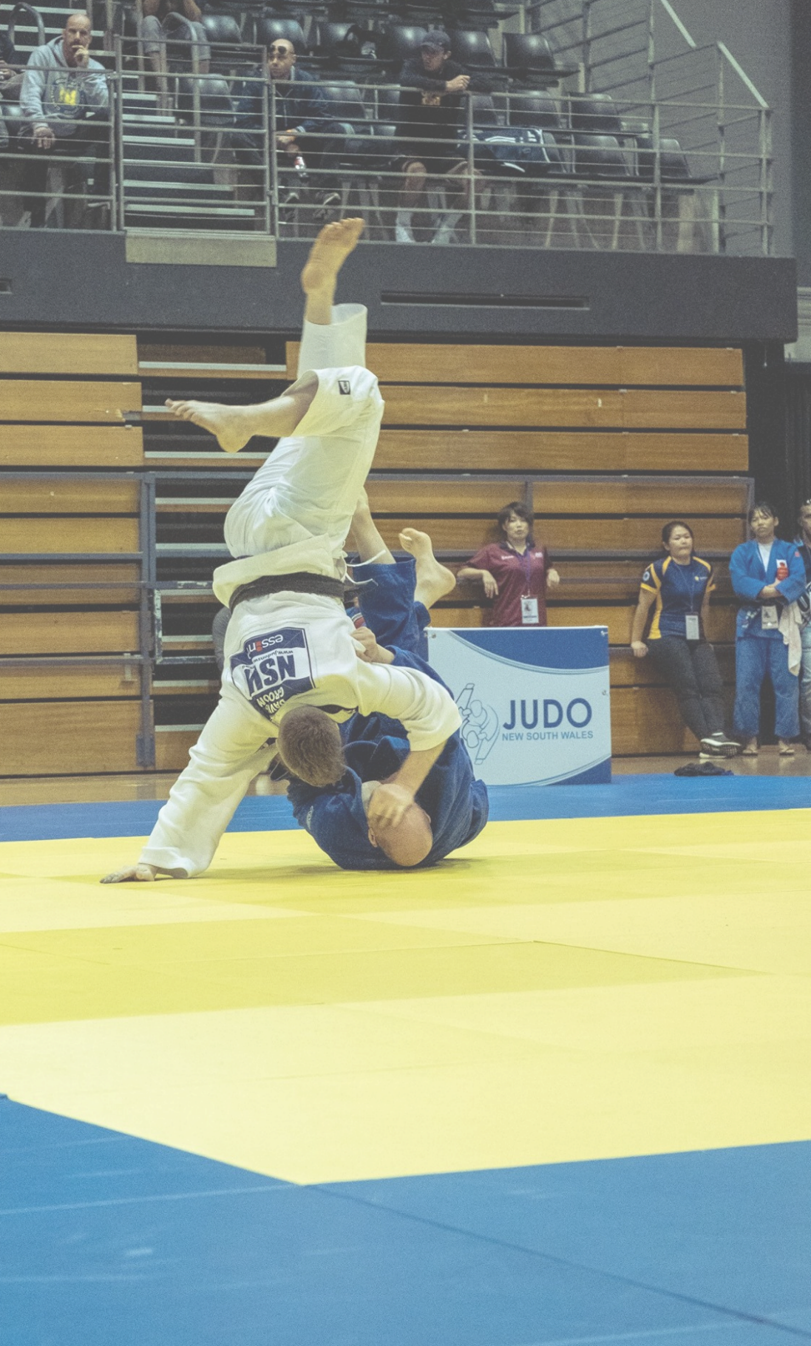

**VOLUNTEER CERTIFICATE**

This is awarded to

**JOE BLOGSS**

in

grateful

recognition of your valuable

contribution to CLUB

XXX

KAREN CITIZEN

**PRESIDENT**

JACK JONES

**HEAD COACH**

Jack Jones

Karer Citizen