2024 HUNTER  WINTER JUDO CHAMPIONSHIPS  SUN 18 AUG 2024 | A Lake Macquarie Games Event
  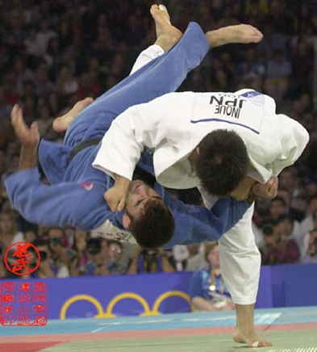 | 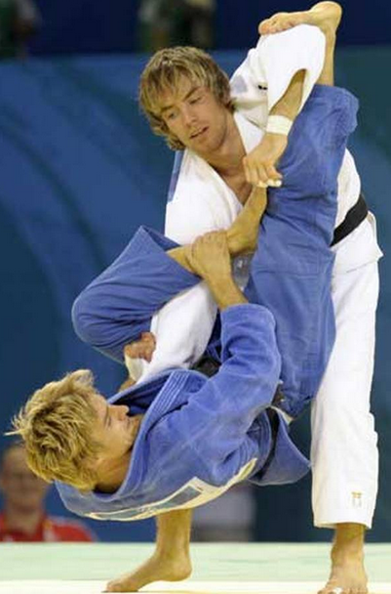 | 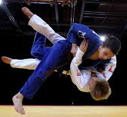 | 

Venue  For link to map CLICK HERE
  Garden Suburb Community Hall  2A Prospect Rd  Garden Suburb  NSW 2289 | 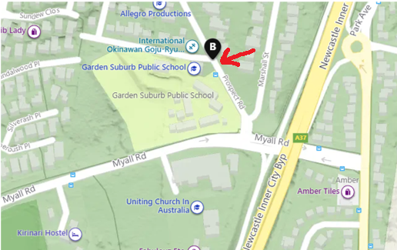
Program | Doors Open | 9.30 am. Weigh in for competition closes 11.00AM
Program times are a guide only & subject to change, based on entry numbers | Events | Basic competition rules explanation …………..…………..…….... 10.00 am  Warm Up & Forming Teams……………………………….…...…… 10.15 am  Lake Macquarie Games Teams Event ………..…………...approx 10.30 am  Lunch Demo Cup & Advanced comp rules overview…......approx 12.30 pm  Hunter Open Competition ……………………...approx 1.00 pm to 3.30 pm
Entry  *PRE-ENTRY CLOSES MIDNIGHT FRI *  Novices can do the competition in their own division | PRE-ENTRY: Teams:$25 Comp:$30 TEAMS & COMP:$45 DEMO:$25 EXTRA DIVISION:$15  SPECTATORS (paid at the door): $2 single / $5 family ENTRY ON DAY: Add $5  Please pre-enter paying into Account no. 196591 BSB 032509 using your name as a reference and email the entry form AS A WORD DOC to kenmckenzie626@yahoo.com.au. For inquiries contact Ken on P: 0421343626 or Noi on pthitiporn@yahoo.com P: 0401027019
Details  If you do not have a mat side coach, we will assign one | This event provides more mat time than a standard competition, in a friendly inter-club environment. You do NOT need to form your own team – teams are formed on the day by matching similar level players. ALL GRADES can do both the teams and competition, but novices are only matched with novice players in both the teams and division events. Green belts 13yrs+ are encouraged to referee.  Where there are matches, we offer separate senior Orange-Green and Blue-Brown belt divisions.  The Demonstration Cup is open to demonstrations such as Ukemi, Kata & Self Defense.  Please let us know ASAP if you are willing to volunteer to make this event a rewarding experience for all. ☺ ☺ Volunteers appointed BEFORE the day get free entry & refreshments! ☺ ☺
Entry Terms  &Conditions  All information and concepts associated with this event are copyright © to Ken McKenzie 2008-2020 , including the teams event, demonstration cup and intermediate event formats, and cannot be used without written permission of Ken McKenzie as the intellectual and document property owner. | - All competitors must be full members of the Judo Federation of Australia or an IJF affiliated body with evidence of current membership.  - Female players MUST wear a white, round neck T-shirt.  - Players must bring a white gi. Blue gi can be worn if called up second but is not required.  - Competition runs to JFA Sporting code. Onus remains on coaches and parents to inform officials of any issues in regards to matching of participants on the day.  - Volunteers, participants and parents/guardians must inform officials of anything that may put themselves or others at risk and acknowledge that judo is a contact sport with inherent risks and fully and totally indemnify the organizers, volunteers and officials in the case of any injury or illness that is not covered by statutory legal rights, including death, regardless of the cause or contributing factors.  - Whilst provision of a medical certificate may be considered, there is no obligation to refund fees.  - Event entry is conditional upon and taken to mean acceptance of these terms & conditions.

Judo Federation of Australia Tournament Age and Weight Groups

PLEASE NOTE: Separate Intermediate (Orange/Green), Advanced (Blue/Brown), Masters Divisions (30yrs +) and Special Needs can be formed IF enough competitor entries are received. If this occurs, lower grade players can also fight in higher grade divisions as an Extra Division
Division | Age | Grades | Categories
Sub-Junior Boys  6 – 8 yrs old THIS YEAR | Must, as a minimum, turn 6yrs and not turn 9 years in this calendar year | NOVICE: White-Yellow or White-Yellow Black Tip  FULL COMP: Yellow belt | Boys: U21, U24, U27, U30, U34, U38, U42 and O42
Sub-Junior Girls  6 – 8 yrs old THIS YEAR | Must, as a minimum, turn 6yrs and not turn 9 years in this calendar year | As Above | Girls: U20, U23, U26, U29, U32, U36, U40 and O40
Junior Boys  9 – 11 yrs old THIS YEAR | Must be 9yrs & not turn 12 in this calendar year | NOVICE: White-Yellow to Yellow-Orange Black Tip  FULL COMP: Orange + | u27, u30, u34, u38, u42, u46, u50, +50 kg
Junior Girls  As Above | Must be 9yrs & not turn 12 in this calendar year | As Above | u29, u32, u36, u40, u44, u48, u52, +52 kg
Senior Boys  12 – 14yrs old this year | 12, 13 &14 years in the calendar year. Must not turn 15 years in this calendar year | As Above | u36, u40, u45, u50, u55, u60, u66, +66 kg
Senior Girls  12 – 14yrs old this year | 12, 13 &14 years in the calendar year. Must not turn 15 years in this calendar year | As Above | u36, u40, u44, u48, u52, u57, u63, +63 kg
Cadet Men  15 – 17yrs old this year | 15, 16 & 17 years in the calendar year. Must not turn 18 years in this calendar year | As Above | u50, u55, u60, u66, u73, u81, u90, +90 kg
Cadet Women  15 – 17yrs old this year | 15, 16 & 17 years in the calendar year. Must not turn 18 years in this calendar year | As Above | u40, u44, u48, u52, u57, u63, u70, +70 kg
Junior Men  15 – 20yrs old this year | 15, 16, 17, 18, 19 & 20 years in the calendar year. Must not turn 21 years in this calendar year | As Above | u55, u60, u66, u73, u81, u90, u100, +100 kg
Junior Women  15 – 20yrs old this year | 15, 16, 17, 18, 19 & 20 years in the calendar year. . Must not turn 21 years in this calendar year | As Above | u44, u48, u52, u57, u63, u70, u78,+78 kg
Senior Men  15 years + this year | 15 years and over in this calendar year | As Above | u60, u66, u73, u81, u90, u100, +100 kg
Senior Women  15 years + this year | 15 years and over in this calendar year | As Above | u48, u52, u57, u63, u70, u78, +78 kg

* All divisions are up to and including the specified weight

Please display the next page and event poster in your club

THE HUNTER  OPEN JUDO CHAMPIONSHIPS
  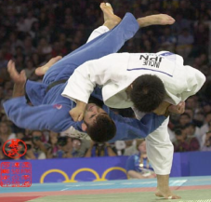 | 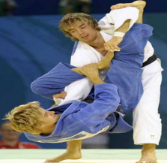 |  | 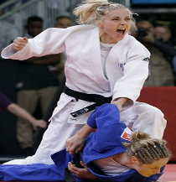
Proudly supported by the Lake Macquarie City Council
10 GREAT REASONS TO ATTEND THIS EVENT!

- We focus on you/your kids getting great value and experiencing success in a friendly inter-club, family environment!

- Our Competition medals are much bigger than standard! ...AND we award Judo Spirit and Player of the Day Trophies!

- Judoka who come to regional events and experience the friendly judo
spirit are generally the ones who stay in judo! Sadly, those who don’t come to events or have a bad experience usually end up quitting.

- Our friendly Teams event is unique! You do NOT need to form your own
team. We match similar level players into two to three teams on the day with medals all round!! This is an ideal stepping stone for Novice or inexperienced judoka and gives them the best chance of success.

- ALL graded players can now do both the teams and the competition,
but novices are only matched with novices. This provides more mat time and experience than a standard competition, in a friendly inter-club environment, without waiting around all day!

- The Demo Cup is open to demonstrations such as Ukemi (Breakfalls), Kata and Self Defense. This gives EVERYONE a chance to participate!!

- Green belts+ get the chance to referee, which earns service points!

- Volunteers appointed prior to the day receive FREE ENTRY AND REFRESHMENTS - just call or text 0421343626 or 0401027019

- Great quality, low cost food and drinks are available all day

- We offer Novice, Intermediate (Orange/Green), Advanced (Blue/Brown), Masters Divisions (30yrs +) and Special Needs where competitor entries are received. If this occurs, lower grade players can also fight in higher grade divisions as an Extra Division.

For more information phone Ken: 0421343626 or Noi: 0401027019 or
email: kenmckenzie626@yahoo.com.au or pthitiporn@yahoo.com

